**Assignment 2: Embedded System Tools**

**1.ARDUINO:-**

Arduino was born at the Ivrea Interaction Design Institute as an easy tool for fast prototyping, aimed at students without a background in electronics and programming. Arduino is an open-source electronics platform based on easy-to-use hardware and software. [Arduino boards](https://www.arduino.cc/en/Main/Products) are able to read inputs - light on a sensor, a finger on a button, or a Twitter message - and turn it into an output - activating a motor, turning on an LED, publishing something online. You can tell your board what to do by sending a set of instructions to the microcontroller on the board. To do so you use the [Arduino programming language](https://www.arduino.cc/en/Reference/HomePage) (based on [Wiring](http://wiring.org.co/)), and [the Arduino Software (IDE)](https://www.arduino.cc/en/Main/Software), based on [Processing](https://processing.org/). Over the years Arduino has been the brain of thousands of projects, from everyday objects to complex scientific instruments. A worldwide community of makers - students, hobbyists, artists, programmers, and professionals - has gathered around this open-source platform, their contributions have added up to an incredible amount of [accessible knowledge](http://forum.arduino.cc/) that can be of great help to novices and experts alike.

**Features of Arduino:-**

* **Inexpensive** - Arduino boards are relatively inexpensive compared to other microcontroller platforms. The least expensive version of the Arduino module can be assembled by hand, and even the pre-assembled Arduino modules cost less than $50
* **Cross-platform** - The Arduino Software (IDE) runs on Windows, Macintosh OSX, and Linux operating systems. Most microcontroller systems are limited to Windows.
* **Simple, clear programming environment** - The Arduino Software (IDE) is easy-to-use for beginners, yet flexible enough for advanced users to take advantage of as well. For teachers, it's conveniently based on the Processing programming environment, so students learning to program in that environment will be familiar with how the Arduino IDE works.
* **Open source and extensible software** - The Arduino software is published as open source tools, available for extension by experienced programmers. The language can be expanded through C++ libraries, and people wanting to understand the technical details can make the leap from Arduino to the AVR C programming language on which it's based. Similarly, you can add AVR-C code directly into your Arduino programs if you want to.
* **Open source and extensible hardware** - The plans of the Arduino boards are published under a Creative Commons license, so experienced circuit designers can make their own version of the module, extending it and improving it. Even relatively inexperienced users can build the [breadboard version of the module](https://www.arduino.cc/en/Main/Standalone) in order to understand how it works and save money.

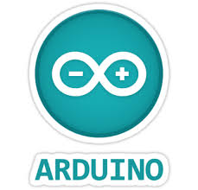

Figure 2.1: Arduino Software

Different Types of Arduino Boards:-

The list of Arduino boards includes the following such as

* Arduino Uno (R3): The Uno is a huge option for your initial Arduino. It consists of 14-digital I/O pins, where 6-pins can be used as PWM ([pulse width modulation](https://www.elprocus.com/pulse-width-modulation-pwm/) outputs), 6-analog inputs, a reset button, a power jack, a USB connection and more. It includes everything required to hold up the microcontroller; simply attach it to a PC with the help of a USB cable and give the supply to get started with a AC-to-DC adapter or battery.
* LilyPad Arduino: The Lily Pad Arduino board is a wearable e-textile technology expanded by Leah “Buechley” and considerately designed by “Leah and SparkFun”. Each board was imaginatively designed with huge connecting pads & a smooth back to let them to be sewn into clothing using conductive thread. This Arduino also comprises of I/O, power, and also sensor boards which are built especially for e-textiles. These are even washable!
* Red Board: The RedBoard a Arduino board can be programmed using a Mini-B USB cable using the Arduino IDE. It will work on Windows 8 without having to modify your security settings. It is more constant due to the USB or FTDI chip we used and also it is entirely flat on the back. Creating it is very simple to utilize in the project design. Just plug the board, select the menu option to choose an Arduino UNO and you are ready to upload the program. You can control the RedBoard over USB cable using the barrel jack.
* Arduino Mega (R3): The Arduino Mega is similar to the UNO’s big brother. It includes lots of digital I/O pins (from that, 14-pins can be used as PWM o/ps), 6-analog inputs, a reset button, a power jack, a USB connection and a reset button. It includes everything required to hold up the microcontroller; simply attach it to a PC with the help of a USB cable and give the supply to get started with a AC-to-DC adapter or battery. The huge number of pins makes this Arduino board very helpful for designing the projects that need bunch of digital i/ps or o/ps like lots buttons.
* Arduino Leonardo: The first development board of an Arduino is the Leonardo board. This board uses one microcontroller along with the USB. That means, it can be very simple and cheap also. Because this board handles USB directly, program libraries are obtainable which let the Arduino board to follow a keyboard of the computer, mouse, etc.

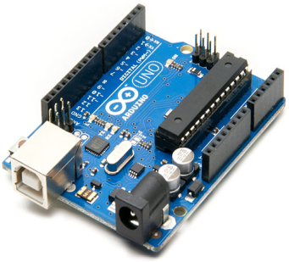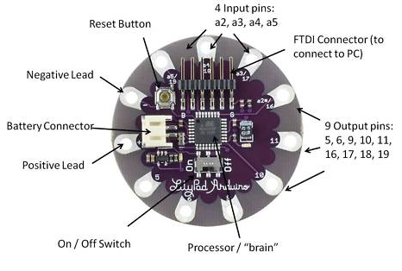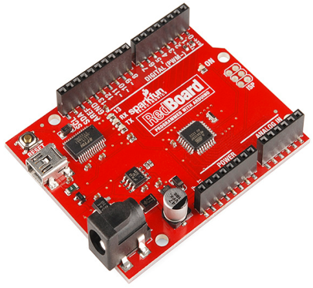

Figure 2.2: Arduino Uno (R3) Figure 2.3: LilyPad Arduino Figure 2.4: Red Board

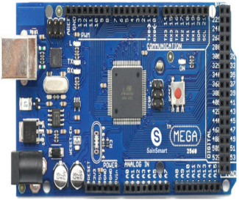 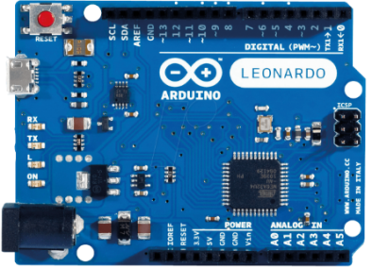

Figure 2.5: Arduino Mega (R3) Figure 2.6: Arduino Leonardo

**2.RASPBERRY PI:-**

The Raspberry Pi is a series of small [single-board computers](https://en.wikipedia.org/wiki/Single-board_computer) developed in the [United Kingdom](https://en.wikipedia.org/wiki/United_Kingdom) by the [Raspberry Pi Foundation](https://en.wikipedia.org/wiki/Raspberry_Pi_Foundation) to promote teaching of basic [computer science](https://en.wikipedia.org/wiki/Computer_science) in schools and in [developing countries](https://en.wikipedia.org/wiki/Developing_countries). The original model became far more popular than anticipated, selling outside its [target market](https://en.wikipedia.org/wiki/Target_market) for uses such as [robotics](https://en.wikipedia.org/wiki/Robotics). It does not include peripherals (such as [keyboards](https://en.wikipedia.org/wiki/Keyboard_(computing)) and [mice](https://en.wikipedia.org/wiki/Mouse_(computing))) or [cases](https://en.wikipedia.org/wiki/Computer_case). However, some accessories have been included in several official and unofficial bundles. **RASPBERRY PI**platform is most used after [ADRUINO](https://components101.com/microcontrollers/arduino-uno). Although overall applications of PI are less it is most preferred when developing advanced applications. Also the RASPBERRY PI is an open source platform where one can get a lot of related information so you can customize the system depending on the need. Here are few examples where RASPBERRY PI 3 is chosen over other microcontrollers and development boards:

1. Where the system processing is huge. Most ARDUINO boards all have clock speed of less than 100MHz, so they can perform functions limited to their capabilities. They cannot process high end programs for applications like Weather Station, Cloud server, gaming console etc. With **1.2GHz clock speed** and **1 GB RAM RASPBERRY PI** can perform all those advanced functions.

2. Where wireless connectivity is needed. RASPBERRY PI 3 has wireless LAN and Bluetooth facility by which you can setup WIFI HOTSPOT for internet connectivity. For **Internet of Things** this feature is best suited.

3. RASPBERRY PI had dedicated port for connecting touch LCD display which is a feature that completely omits the need of monitor.

4. RASPBERRY PI also has dedicated camera port so one can connect camera without any hassle to the PI board.

5. RASPBERRY PI also has PWM outputs for application use.

There are many other features like HD steaming which further promote the use of RASPBERRY PI.

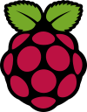 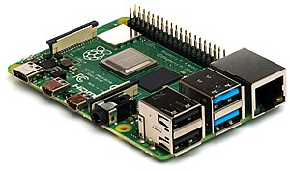

Figure 2.7: Raspberry Pi Logo Figure 2.8: Raspberry Pi

**Generations of released models:-**

| Family | Model | Form Factor | Ethernet | Wireless | GPIO | Released | Discontinued |
| --- | --- | --- | --- | --- | --- | --- | --- |
| Raspberry Pi 1 | B | Standard  (85.60 × 56.5 mm) | Yes | No | 26-pin | 2012 | Yes |
| A | No | 2013 | Yes |
| B+ | Yes | 40-pin | 2014 |  |
| A+ | Compact  (65 × 56.5 mm) | No | 2014 |  |
| Raspberry Pi 2 | B | Standard | Yes | No | 2015 |  |
| Raspberry Pi Zero | Zero | Zero  (65 × 30 mm) | No | No | 2015 |  |
| W/WH | Yes | 2017 |  |
| Raspberry Pi 3 | B | Standard | Yes | Yes | 2016 |  |
| A+ | Compact | No | 2018 |  |
| B+ | Standard | Yes | 2018 |  |
| Raspberry Pi 4 | B (1GB) | Standard | Yes | Yes | 2019[[26]](https://en.wikipedia.org/wiki/Raspberry_Pi#cite_note-:4-26) |  |
|  |  |

Figure 2.9: Table for generations of Raspberry Pi

**3.ARM Cortex:-**

The ARM Cortex-M families are ARM microprocessor cores which are designed for use in microcontrollers, ASICs, ASSPs, FPGAs, and SoCs. Cortex-M cores are commonly used as dedicated microcontroller chips, but also are "hidden" inside of SoC chips as power management controllers, I/O controllers, system controllers, touch screen controllers, smart battery controllers, and sensors controllers.

Though 8-bit microcontrollers were very popular in the past, Cortex-M has slowly been chipping away at the 8-bit market as the prices of low-end Cortex-M chips have moved downward. Cortex-M have become a popular replacements for 8-bit chips in applications that benefit from 32-bit math operations, and replacing older legacy ARM cores such as ARM7 and ARM9.

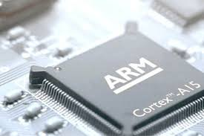

Figure 2.10: ARM Cortex

**4.INTEL GALILEO:-**

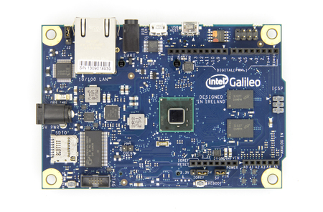 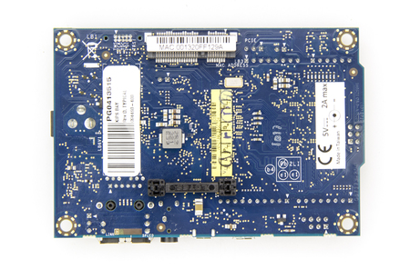

Figure 2.11: Intel Galileo Front Figure 2.12: Intel Galileo Back

Intel Galileo is the first in a line of Arduino-certified development boards based on Intel x86 architecture and is designed for the maker and education communities. Intel released two versions of Galileo, referred to as Gen 1 and Gen 2. These development boards are sometimes called "Breakout boards". Galileo is a microcontroller board based on the Intel® Quark SoC X1000 Application Processor, a 32-bit Intel Pentium-class system on a chip (datasheet). It’s the first board based on Intel® architecture designed to be hardware and software pin-compatible with Arduino shields designed for the Uno R3. Digital pins 0 to 13 (and the adjacent AREF and GND pins), Analog inputs 0 to 5, the power header, ICSP header, and the UART port pins (0 and 1), are all in the same locations as on the Arduino Uno R3. This is also known as the Arduino 1.0 pinout. Galileo is designed to support shields that operate at either 3.3V or 5V. The core operating voltage of Galileo is 3.3V. However, a jumper on the board enables voltage translation to 5V at the I/O pins. This provides support for 5V Uno shields and is the default behavior. By switching the jumper position, the voltage translation can be disabled to provide 3.3V operation at the I/O pins. Of course, the Galileo board is also software compatible with the Arduino Software Development Environment (IDE), which makes usability and introduction a snap. In addition to Arduino hardware and software compatibility, the Galileo board has several PC industry standard I/O ports and features to expand native usage and capabilities beyond the Arduino shield ecosystem. A full sized mini-PCI Express slot, 100Mb Ethernet port, Micro-SD slot, RS-232 serial port, USB Host port, USB Client port, and 8MByte NOR flash come standard on the board.

**5.DIFFERENT TYPES OF SENSORS:-**

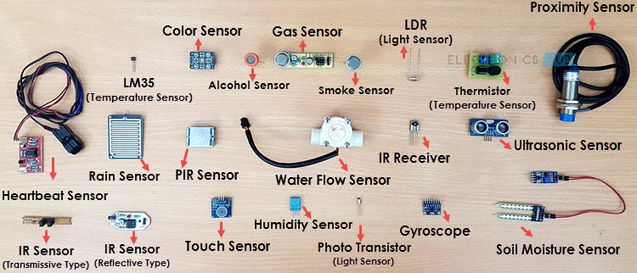

Figure 2.13: Different types of sensors.

1. **Temperature Sensor**

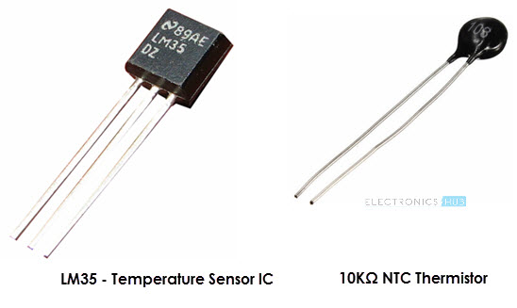

Figure 2.14: Temperature Sensor

One of the most common and most popular sensor is the Temperature Sensor. A Temperature Sensor, as the name suggests, senses the temperature i.e. it measures the changes in the temperature. In a Temperature Sensor, the changes in the Temperature correspond to change in its physical property like resistance or voltage. There are different types of Temperature Sensors like Temperature Sensor ICs (like LM35), Thermistors, Thermocouples, RTD (Resistive Temperature Devices), etc. Temperature Sensors are used everywhere like computers, mobile phones, automobiles, air conditioning systems, industries etc.

#### Proximity Sensors

#### Types of Sensors Image 4

Figure 2.15: Proximity Sensors

A Proximity Sensor is a non-contact type sensor that detects the presence of an object. Proximity Sensors can be implemented using different techniques like Optical (like Infrared or Laser), Ultrasonic, Hall Effect, Capacitive, etc. Some of the applications of Proximity Sensors are Mobile Phones, Cars (Parking Sensors), industries (object alignment), Ground Proximity in Aircrafts, etc.

#### Infrared Sensor (IR Sensor)

#### Types of Sensors Image 5

#### Figure 2.16: Infrared Sensor (IR Sensor)

IR Sensors or Infrared Sensor is light based sensor that are used in various applications like Proximity and Object Detection. IR Sensors are used as proximity sensors in almost all mobile phones. There are two types of Infrared or IR Sensors: Transmissive Type and Reflective Type. In Transmissive Type IR Sensor, the IR Transmitter (usually an IR LED) and the IR Detector (usually a Photo Diode) are positioned facing each other so that when an object passes between them, the sensor detects the object. The other type of IR Sensor is a Reflective Type IR Sensor. In this, the transmitter and the detector are positioned adjacent to each other facing the object. When an object comes in front of the sensor, the sensor detects the object. Different applications where IR Sensor is implemented are Mobile Phones, Robots, Industrial assembly, automobiles etc.

#### Ultrasonic Sensor

#### Types of Sensors Image 6

#### Figure 2.17: Ultrasonic Sensor

#### An Ultrasonic Sensor is a non-contact type device that can be used to measure distance as well as velocity of an object. An ultrasonic sensor works based on the properties of sound waves with frequency greater than human audible range. Using the time of flight of the sound wave, an Ultrasonic Sensor can measure the distance of the object (similar to SONAR). The Doppler Shift property of the sound wave is used to measure the velocity of an object.

### ****E) PIR Sensor:****

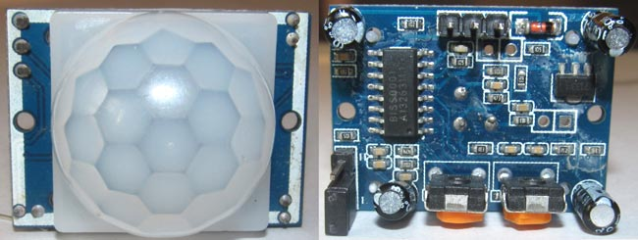

#### Figure 2.18: PIR Sensor

PIR sensor stands for **Passive Infrared sensor**. These are used to detect the motion of humans, animals or things. We know that infrared rays have a property of reflection. When an infrared ray hits an object, depending upon the temperature of the target the infrared ray properties changes, this received signal determines the motion of the objects or the living beings. Even if the shape of the object alters, the properties of the reflected infrared rays can differentiate the objects precisely.